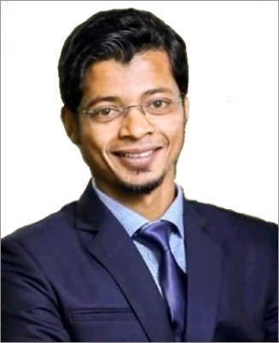***Curriculum Vitae***

*of*

***Md. Shah Jalal***

***Mailing Address:***

*Cell: 01776-086484, 01722-953253*

*Email:shahsazzadur@gmail.com*

*14/2, J.N. Saha Road, Lalbagh, Dhaka-1211*

***Objectives***

*To pursue a work by which I can serve by using my vision, positive attitude, interpersonal relationship, communication skill to take the challenges that will also ensure me the opportunity to grow by learning new skills and knowledge as well as develop your institution.*

***Academic Certification***

***Masters of Business Administration (M.B.A)***

*Name of Institute : Peoples University*

*Year : Running*

***Bachelor of Business Administration (B.B.A)***

*Name of Institute : Darul Ihsan University*

*Year of Completion : 2011*

*Result : CGPA- 3.52 out of 4.00*

***Higher Secondary Certificate (H.S.C)***

*Name of Institute : Stamford College, Dhaka*

*Group : Science*

*Board : Dhaka*

*Year of Completion : 2007*

*Result : GPA- 2.70 out of 5.00*

***Secondary School Certificate (S.S.C)***

*Name of Institute : Farid Uddin Siddique High School*

*Group : Science*

*Board : Dhaka*

*Year of Completion : 2005*

*Result : GPA- 3.63 out of 5.00*

***Job Experience***

* *Worked as a Area Sales Manager of Sini Care Bangladesh Ltd. in 3 years.*
* *Worked as a Cashier of Nazrul Iron in 5 years.*

***Language Proficiency***

*Bangali (Excellent Reading, Writing & Speaking)*

*English (Excellent Reading, Writing & Speaking Medium)*

***Computer Skill***

*M/S Word, M/S Excel, Multimedia, Email, Internet browsing etc.*

***Self Appraisal***

* *Honest and Punctual.*
* *Quick Learner.*
* *Like to take the challenge.*
* *Hard Working.*
* *Amiable and Friendly.*

***Personal Information***

*Name : Md. Shah Jalal*

*Father’s Name : Abdur Razzak*

*Mother’s Name : Joynab*

*Permanent Address : 38/33/A, Islam Bagh, Chawkbazar, Dhaka-1211*

*Present Address : 14/2, J.N. Saha Road, Lalbagh, Dhaka-1211*

*Date of Birth : 20/11/1990*

*Nationality : Bangladeshi*

*Blood Group : B+(ve)*

*Religion : Islam*

*Height : 5’6”*

*Marital Status : Married*

*Gender : Male*

***Reference***

|  |  |
| --- | --- |
| *Md. Motaleb Hossain*  *Asst. Head Master*  *Ashraf Ali High School, Islambagh,*  *Dhaka.*  *Cell: 01711-226778* | *Hossain Ahmed*  *CIO at Bank Asia Ltd.*  *Dhaka.*  *Cell:01713-452835* |

***Declaration***

*All of the information have provided are true my knowledge and I will be able to submit all relative certificates if it essential.*

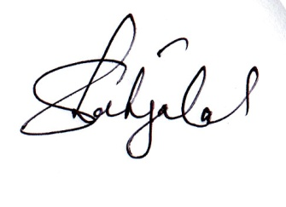

**Md. Shah Jalal**